RESIDENT HANDBOOK

Welcome to your new community! We are excited that you chose to live at The Standard at Atlanta this year and look forward to getting to know you. Our mission is to deliver unrivaled customer service and an unforgettable experience to our residents. To help make your experience pleasant and knowledgable, please read through the Resident Handbook to familiarize yourself with the community, important rules to remember, and important contact information.

Please don’t hesitate to stop by our office if you need any help or just to introduce yourself! We are also quick to respond to text messages at 678-837-7945 if you have any questions!

Thanks again for choosing The Standard at Atlanta!

Welcome home!

Sincerely,

The Standard at Atlanta
Table of Contents

- Office Information Page 3
- Rental Payments and Resident Portal Page 3
- Life in the Community Page 4
- Community Information Page 5, 6
- Important Numbers Page 6
- Maintenance Page 7, 8

OFFICE INFORMATION

Address: 708 Spring Street NW Atlanta, GA 30308
Phone: 678-515-5319
Website: thestandardatlanta.com
Text Us: 678-837-7945

Office Hours are Monday through Friday 10 am to 6 pm, 11 am to 5 pm Saturday and Sunday 12 pm to 5 pm

The staff in the office consists of the following personnel:
- Bianka Reynolds, Community Manager – Oversees the leasing and operations of the entire property.
- Peyton Dailey, Associate Community Manager – Manages the leasing and renewal process, including transfers, as well as customer service related items.
- Danielle Fairey, Resident Services Manager – Handles resident accounts, customer service and our Resident Life program.
- Leasing and Marketing Assistants – Assist the Leasing and Marketing Manager in the leasing and renewal process, including transfers.
- Kerion Patrick, Maintenance Supervisor– Responsible for timely maintenance request completion, routine maintenance and inspections, and ensuring that the grounds are kept clean.
- Community Ambassadors – Those in this position are responsible for touring the property, guiding residents through the leasing process, executing resident events, and to help answer general questions you may have.

PAYMENTS

Monthly installments are due on the 1st of each month, regardless of whether it is a holiday or weekend. The payment is late on the 4th of the month at 12 pm, the fastest way to submit on-time payments is through the Resident Portal where you can set up recurring scheduled payments to avoid late fees (processing fees may apply). If paying after hours, please submit payment through resident portal or place payment in the designated drop box. If paying by personal check or cashier’s check please make sure your full name and apartment number is listed on the memo line.
*We do not accept cash or money orders.
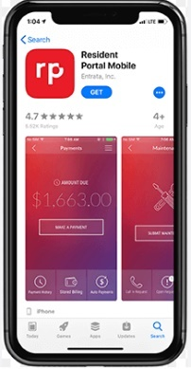

The Resident Portal can be accessed through the property website,
thestandardatlanta.com or by downloading the Resident Portal mobile app through
Apple App Store or Google Play Store. The Resident Portal is your resource to find out
about community events, contact the property, pay rent, set up monthly recurring
payments, or submit maintenance requests.

If you have not signed up already please create a new account. It only takes a
few minutes!

YOUR COMMUNITY AND YOU

The Standard at Atlanta is committed to building a community where people feel they belong and are cared for. Throughout the year we will be planning a variety of events aimed to help you have a well-rounded experience, become better acquainted with your roommates and neighbors, and to be involved in activities beyond current routine.

The Standard at Atlanta will host events throughout the year that are focused on Philanthropic, Academic, Wellness, and Social. Each event is tailored with the intent to add value to your life. There will be volunteer opportunities to get involved in the local community, new academic and life skills to learn like “How to Complete a Cover Letter” or take a professional headshot, grab and go breakfast to start your day right, and an array of social events from pool parties to themed trivia nights.

We highly recommend that you follow us on social media to stay informed about all upcoming events.

: thestandardatl
: The Standard at Atlanta
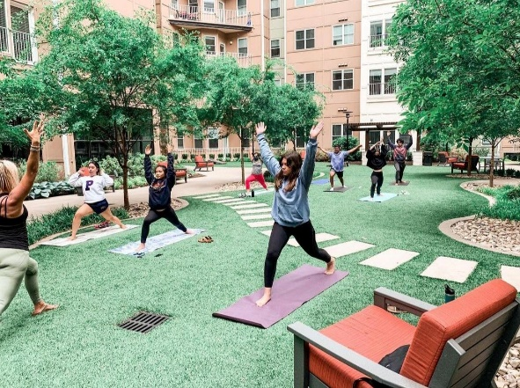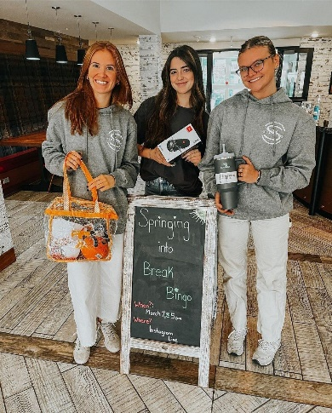

Semi-annually we provide you with a chance for your voice to be heard through our You Speak We Listen survey. You as the resident spend the most time on site and participate in the events. We want to know what works, and what doesn’t. We are always looking to improve and with your input we certainly can.

Be on the lookout for emails with the link to submit your response.

COMMUNITY INFORMATION

The Standard at Atlanta is committed to complying with all federal, state, and local fair housing laws. This means our staff has an obligation to treat each individual consistently. To do so, and to create a comfortable and exceptional community, we have established guidelines for everyone in our community to follow. In accordance with Fair Housing laws we ask for any requests to be submitted in writing to on-site team. We appreciate your cooperation.

Residents must follow the Rules and Regulations as outlined in your Housing Contract. A copy of your housing contract can be located in the documents section of your Resident Portal referenced on page 3 of this guide. The referenced section of your Housing Contract covers several topics and resulting violations and fines that include but are not limited to:

- Access, Lock Outs, and Keys
- Visitor/Guest Policy
- Prohibited items within your unit and common area spaces
- Use of Amenities
- Noise and Parties
- Smoking
- Parking
- Animals
- Utilities

Additionally, pay close attention to posted community signs as well, as the property has specific guidelines.

COMMUNITY AMENITIES
Amenity Hours
- Pool and Hot Tub- 10 am to 10 pm
- Gym- 24/7
- Clubhouse- 24/7
- Study Rooms – 24/7
- 18th Floor Lounge – 24/7

Building Access Tips
- All exterior doors, elevators, amenities, unit front doors and bedroom doors all require your fob.
- Do not leave doors propped open to allow non-resident entry.
- Do not allow people to “piggy-back” off of you and enter resident only areas.
- Do not give your key to a visitor or guest.
- If key is lost please let a staff member know and we will make you a replacement for $50.

Pool and Hot Tub
- All visitors and guests must be accompanied by a resident.
- No glass or other hazardous objects in or around pool and hot tub.
- There is no lifeguard on duty, swim at your own risk.
- No children under the age of 15 should be left unattended.
- All trash must be disposed of properly, fines may occur if not properly disposed.
- No smoking in or around the pool and hot tub area.
- No diving into pool or hot tub.
- Pool and Hot Tub will close during any severe or dangerous weather conditions.

Mail and Packages
- Flat mail is sorted and disbursed into unit mailboxes in the mail room by USPS located in the main lobby area on the first floor.
- Each apartment has one mail box and each resident has their own key.
- If key is lost please let a staff member know and we will make you a replacement for $50.
- Packages are delivered by carriers and put in our sorting area. Staff members check in and label all packages to appropriate units and residents.
- Luxer One - You will receive a package code via email/or app that notifies you once your package has been checked in. Please wait until you receive the Luxer code, if you receive a delivery notification from the sender that does not signify the package has been processed by our staff. The Luxer room is located on the 12th floor past the trash room.
- Staff is not responsible for lost or stolen packages, please contact the carrier directly.
- The staff will not accept any large furniture, large area rugs, or alcohol on behalf of residents.
- packages will be stored appropriately in the package room refrigerator and held for 72 hours prior to disposal.

Parking
- Guest or overnight parking is available on the first floor of the parking garage BEFORE the resident entry gate. All guests must collect a ticket upon entry and pay to exit.
- Retail parking is only for retail customers.
- The parking lot is actively booted/towed by ParkSimple.

Trash/Recycling
- Trash rooms are located on each floor.
- Recycling is locatedin the blue bins along the back road of the parking garage.
- All boxes and cardboard should be broken down flat prior to disposal. Cardboard should not be thrown down trash chute and should be taken to recycling room.
- Be sure to put appropriate recycling in correct labeled bins.

Important Numbers:
- Courtesy Officer-678-515-5319
- Police-Emergency 911; Non-Emergency-404-546-0311
- Fire Department-Emergency 911; Non-Emergency-404-546-0311
- Poison Control-80th F0-222-1222
- Hospital- Emory University Midtown 404-686-4411
- Towing Company- ParkSimple

MAINTENANCE

Non-Emergency maintenance items can be submitted by logging into your Resident Portal. The property aims to have all non-emergency requests completed within 48 business hours. Any work order that requires us to call out an outside vendor to complete, may take additional time, but will be completed within a reasonable time-period. Any resident-caused damage to the home will be charged to your account after the work is completed.
*Note that service requests entered through only the Resident Portal will not be received until the following morning.

Emergency maintenance is a maintenance request made after-hours. Issues may arise after hours that require immediate maintenance attention. These are situations that present a danger to people or property and include; fire, leaking pipes, flooding, toilet issues in units that have only one bathroom, no heat or AC if temperature is below 50 or above 85, or no water/power to the unit. If you are in need of emergency Maintainance assistance, please call our after-hours number at 678-515-5319.

Maintenance Tips:
Toilet
- Dispose properly. This one is the easiest to follow of all the toilet maintenance tips. Avoid flushing anything but human waste and toilet paper down the toilet drain. Feminine products, diapers, cotton balls and swabs, paper towels, and other paper-based materials clog toilets much faster than toilet paper and waste. Keep these items out of the toilet and only flush human waste and toilet paper.
- Clean the toilet. Though it seems obvious to clean your toilet, residents often neglect this task, resulting in insufficient or infrequent cleaning. With regular cleaning, a toilet experiences fewer clogs in the bowl and under the rim of the seat. Plus, over time, the effort required to clean the toilet decreases.
- Keep a plunger on hand.
- Shut-off valve. The shut-off or stop valve cuts off the water supply to the toilet. It is located either under or behind the fixture. It needs to turn easily to be considered functional. It needs to be repaired or replaced if it provides resistance or does not turn at all. Check this valve at least once a month to ensure it always works properly.
Garbage Disposal
- Regularly Run the Garbage Disposal

One of the best things you can do to keep the garbage disposal in good working order is simply to run it at least once a day. Even if you do not have anything to grind up, run the garbage disposal with cold water to ensure that the blades do not become rusted from lack of use. It is also a good idea to take this time to put ice cubes into the garbage disposal. The hard cubes will get chopped up by the blades and help clean out any waste that is still stuck to the sides of the appliance or to the inside of the drainpipe.
- Avoid Products That Damage Disposals

Another easy maintenance step is to simply avoid putting items into the disposal if you know that they can potentially harm the disposal or the pipes. Common food items that should not be put into a garbage disposal include banana skins, broccoli, celery, corn husks, potato peels, bones, eggshells, coffee grounds, and fat.

Washer and Dryer
- Clean Them Regularly
When grime is allowed to build up inside your washing machine or dryer, the less effectively and efficiently it will be able to do its job. That is why cleaning both machines regularly are important so you can continue to enjoy clean, dry clothes on laundry day!
- Keep The Doors Open
As much as possible, you should try to keep your washer and dryer doors open or ajar whenever they are not being used. If you close your washer or dryer door right after using it, moisture can get trapped inside the machine and cause musty odors or mold and mildew growth!
- Wash Your Dryer’s Lint Trap
You already know how important it is to remove lint from your dryer’s lint trap regularly after every use, but did you know you should also wash it periodically too? Washing the lint trap with soap and water every few months will help remove any detergent or fabric softener residue buildup limiting airflow through the trap.
After Bathing
- Wiping down the surface with a dry towel after each use will limit the amount of residue, but proper cleaning should still be performed weekly.
Leave the bathroom door open with the exhaust fan running for at least 30 minutes after showering or bathing.

Tripped Breaker
Resetting a circuit breaker is simple if you know how and will restore power to the room or rooms affected if there is not an outage.
• Locate Circuit Breaker: Find your electrical panel and open the cover.
Locate the Tripped Breaker: Circuit breakers are small, usually horizontal switches, and may or may not be labeled (e.g., “kitchen,” “bathroom,” etc.). The tripped circuit breaker will be in the “off” position or a middle position between “on” and “off.” Move the circuit breaker to the full “off” position and then back “on” to restore power to the affected rooms or areas.
• Breaker Trips Again: If the circuit breaker trips again, it could be for several reasons: too many lamps and appliances plugged into the circuit; a damaged cord; a short-circuit in a receptacle, switch, or fixture; or circuit breakers.

